1.Connect the parallel data cable to the parallel port of the printer.

2. On the printer control panel, press and hold down the Start + Cancel
keys. Without releasing the keys, power the printer on. Continue holding
the Start and Cancel keys down for five seconds, then release them until you see “WAITING FOR PROGRAM DOWNLOAD” on the LCD
3. Then follow below procedure

The following procedure may seem easier for you to use. You still MUST setup a Generic Text Only printer as your default printer.

Downloading microcode using the Run Facility

Click on the start button. .

From the Start Menu, Select the Run icon to bring up the Run window.

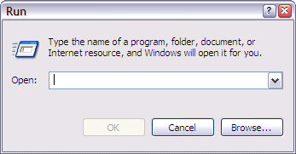

Click on the Browse … button.

Select the code file you want to load by clicking on it. Then click on the Open button.

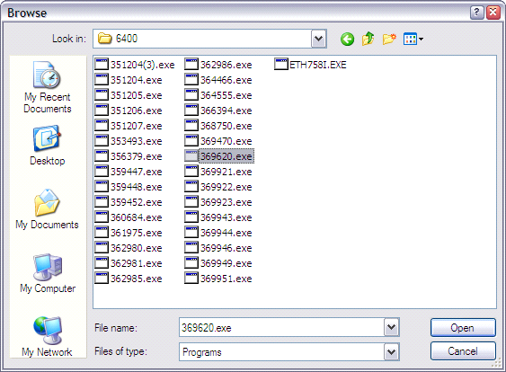

Click on the highlighted file to highlight it, then click on it again and add a space and –pb as shown below.

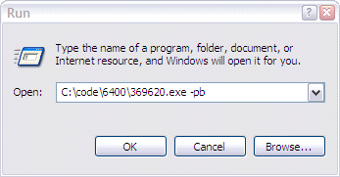

With the printer in download mode, click on the OK button to load the code to the printer.

